**Error Detection & Correction**

<https://www.tutorialspoint.com/data_communication_computer_network/error_detection_and_correction.htm>

<https://www.geeksforgeeks.org/error-detection-in-computer-networks/>

There are many reasons such as noise, cross-talk etc., which may help data to get corrupted during transmission. The upper layers work on some generalized view of network architecture and are not aware of actual hardware data processing. Hence, the upper layers expect error-free transmission between the systems. Most of the applications would not function expectedly if they receive erroneous data. Applications such as voice and video may not be that affected and with some errors they may still function well.

Data-link layer uses some error control mechanism to ensure that frames (data bit streams) are transmitted with certain level of accuracy. But to understand how errors is controlled, it is essential to know what types of errors may occur.

**Types of Errors**

There may be three types of errors:

* **Single bit error**

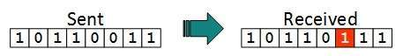

In a frame, there is only one bit, anywhere though, which is corrupt.

* **Multiple bits error**

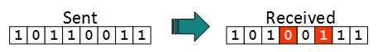

Frame is received with more than one bits in corrupted state.

* **Burst error**

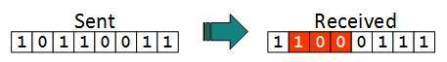

Frame contains more than1 consecutive bits corrupted.

Error control mechanism may involve two possible ways:

* Error detection
* Error correction

Error Detection

Errors in the received frames are detected by means of Parity Check and Cyclic Redundancy Check (CRC). In both cases, few extra bits are sent along with actual data to confirm that bits received at other end are same as they were sent. If the counter-check at receiver’ end fails, the bits are considered corrupted.

**Parity Check**

One extra bit is sent along with the original bits to make number of 1s either even in case of even parity, or odd in case of odd parity.

The sender while creating a frame counts the number of 1s in it. For example, if even parity is used and number of 1s is even then one bit with value 0 is added. This way number of 1s remains even. If the number of 1s is odd, to make it even a bit with value 1 is added.

* 1 is added to the block if it contains an odd number of 1’s, and
* 0 is added if it contains an even number of 1’s

Even Parity

The receiver simply counts the number of 1s in a frame. If the count of 1s is even and even parity is used, the frame is considered to be not-corrupted and is accepted. If the count of 1s is odd and odd parity is used, the frame is still not corrupted.

If a single bit flips in transit, the receiver can detect it by counting the number of 1s. But when more than one bits are erro neous, then it is very hard for the receiver to detect the error.

**Cyclic Redundancy Check (CRC)**

CRC is a different approach to detect if the received frame contains valid data. This technique involves binary division of the data bits being sent. The divisor is generated using polynomials. The sender performs a division operation on the bits being sent and calculates the remainder. Before sending the actual bits, the sender adds the remainder at the end of the actual bits. Actual data bits plus the remainder is called a codeword. The sender transmits data bits as codewords.

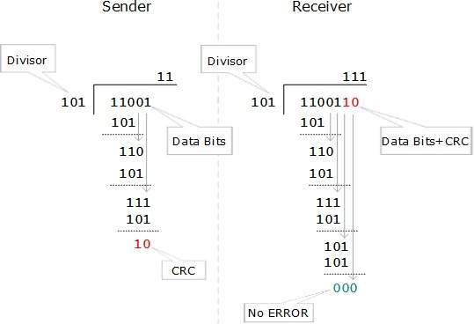

At the other end, the receiver performs division operation on codewords using the same CRC divisor. If the remainder contains all zeros the data bits are accepted, otherwise it is considered as there some data corruption occurred in transit.

Error Correction

In the digital world, error correction can be done in two ways:

* **Backward Error Correction** When the receiver detects an error in the data received, it requests back the sender to retransmit the data unit.
* **Forward Error Correction** When the receiver detects some error in the data received, it executes error-correcting code, which helps it to auto-recover and to correct some kinds of errors.